**1.PROBLEM**

**CSS in-line styling - div element**

Pink Frag Event Organizer is a company grown from Strength to Strength, entirely committed to a flexible, "hands on approach" – paying the closest attention to customer's needs and always providing a professional service in managing every sorts of events.  
  
The company's highly creative team of event organizers always excel in creating unique brand identity and out-of-the-box events that speaks on its own. They assigned the task of creating a webpage for their upcoming extravaganza "Best Talents of 2017", an annual award ceremony to Vanton web designing company. But the creative team was not much satisfied with the stylings used in the page designed by Vanton.  
  
The designing company needs your help to make the web page look more attractive. Hence create a web page with internal styling using div element.

**Hints :**

**internal styling**

An inline style may be used to apply a unique style for a single element.

Syntax :

<tagname style="css declarations"></tagname>

**Content :**  
**H1**- Pink Frag Event Organizer  
**HR**  
**H2**- Service Description  
**P**- We are indulged in offering a Promotional Event Management. These services are provided by our team of professionals as per the requirement of the client. These services are highly praised for their features like sophisticated technology, effective results and reliability. We offer these services in a definite time frame and at affordable rates.  
**HR**  
**H2**- Features  
**H5**- Customized services  
**H5**- On-time completion  
**H5**- Execution in tandem with clients demand  
**HR**  
**H2**- About Us  
**p** - Pink Frag Event is a reputed organization, which has come into being in 2009, as a Sole Proprietorship Firm, with a sole aim of achieving the trust and support of large customers. We have indulged our all endeavors towards offering trustworthy Wedding Event Management, Promotional Event Management, Birthday Party Management and many more. All our services are reliable and offered keeping the exact customers’ preferences and choice in mind. To offer these services, we have hired specialized professionals, who are capable of understanding as well as accomplishing the specific customers’ desires. <br /> We have adopted modern technology, to cope up with the challenges of industry. We keep all quality parameters in mind, so that we cannot make any compromise in terms of the excellence of products.  
**HR**  
**Div**  
H2 - Contact Us  
H3 - Address  
p - 14/509A,Sterlin Street,Nungambakkam  
Chennai - 600034.  
H3 - Mobile  
p - Manager-9596645125  
H3 - Landline  
p - 0422-2727272  
H3 - EMail  
p - pinkfragevent123@gmail.com   pinkfragOfficial@gmail.com  
  
**div**  
Give **Contact us**fully in a div.  
Change contact us Background as green(**#bbf4b6**)   
Text color as blue(**#0c0068**)  
  
**h2** - Contact us title alone in Orange color(**#de9707**)  
  
**Constraints :**  
The style should be of inline style.  
The Contact us content should be present inside the div.  
The content given in the template should not be changed.  
The color and the background color of the div should be same as given in the content.  
The color of the h2 tag  should be same as given in the content.  
  
**Note :**  
Content of the page should be present as shown in the screenshot.  
Kindly refer the content which is given as a part of description.  
  
**Sample Screenshot 1 :**  
  
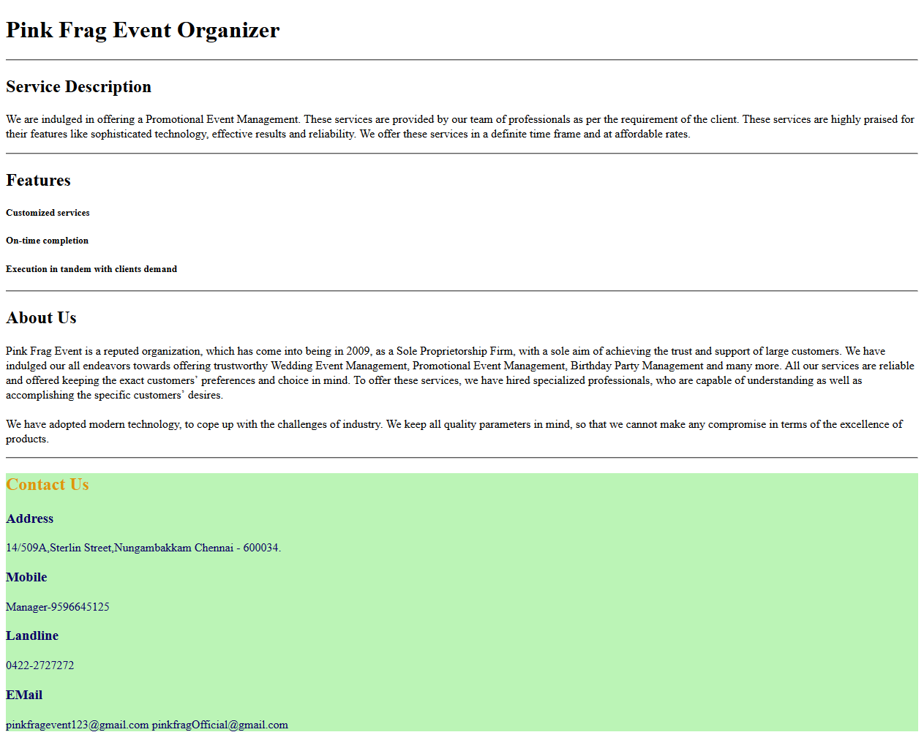

2.HTML Basics - span tag

Eventsforce Solutions is an emerging brand in Event Management with attractive webpage. The developer of the webpage has to present the informations in it in such a way that, it interests the customers at the very moment they see it. For achieving such a cause, the important facts about the organization has to be highligted from the common content. Let us help the developer to create the webpage that will show the informative webpage with highlighted facts using the span element.

Content :  
Eventsforce helps you manage events more effectively by simplifying your everyday tasks and processes. It can deliver all the functionality you require for any type of event – regardless of size or complexity. More importantly,  Eventsforce solutions can help you save time, cut costs and make better use of your event data.  
  
span - simplifying your everyday tasks and processes  
span - deliver all the functionality  
span - help you save time, cut costs    
  
Note :  
Content of the page should be present as shown in the screenshot.  
Kindly refer the content which is given as a part of description.  
  
Sample Screenshot 1 :  
  
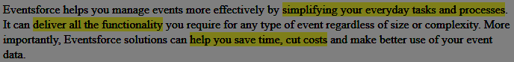

3.HTML Basics - Formatted Attributes

Suhas works as an Administrative Assistant in a reputated organisation named Winrow Solutions. His primary responsibility is to maintain the details of the Company employees like name, address, mobile number, email id etc,. As a part of the quarterly audit, Suhas was assigned the task of presenting all the employee details similar to a telephone book in a html page. A telephone book has the specific format of displaying the details like the name should be in bold, address should be in italics ,email id and mobile number should be underlined.



Let us help Suhas for creating the HTML page with the mentioned constraints.

 Hints : Tag <b> The <b> tag specifies bold text. Tag <i> The content of the <i> tag is usually displayed in italic. Tag <strike> The <strike> tag defines strikethrough text. Tag <u> The <u> element was used to define underlined text.

Content :

title - Phone Book  
H1  - Phone Book  
div id - address1  
b - Micheal Jackson  
u - michael346danceacademy@hotmail.in  
u- +442015462358  
strike - +446695326580  
i - 1750 East 4th Street,Los Angeles,California .  
hr

div id - address2  
b - Charlie Puth  
u - charlie50Dangerous@gmail.com  
u - +441920462355  
strike - +445562321997  
i - 3909 Witmer Road,Niagara Falls, New York .

hr  
div id - address3  
b - Justin Bieber  
u - bieber16@yahoo.com  
u - +446595462399  
strike - +449995326508  
i - 125 Micheal street,Bergen,Norway .

hr  
  
Constraints :  
The text inside the title tag in the html page should be "Phone Book".  
H1 tag should contain the text as "Phone Book".  
Div tag count should be 3.  
Each div should contain 'b' tag, 'u' tag, 'strike' tag and 'i' tag.  
Each div should be separated by 'hr' tag.  
First div id should be "address1".  
Second div id should be "address2".  
Third div id should be "address3".  
  
Note :  
Content of the page should be present as shown in the screenshot.  
Kindly refer the content which is given as a part of description  
  
Sample Screenshot 1 :  
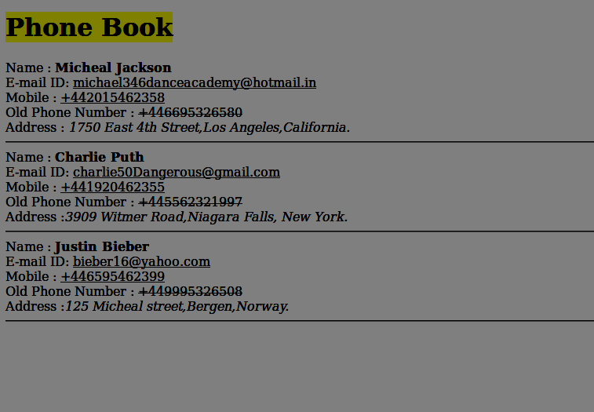

4.HTML Basics - div tag

Eventsforce Solutions is an emerging brand in Event Management for events like Weddings, Corporate events, Birthdays, etc., Nowadays, every information is shared through the internet as it has become the easiest mode of communication everywhere. So the company has planned to launch their online website for better customer interaction and efficient service delivery. The developer of the webpage has to show difference between each section of the content in the page. Let us help the developer to create the webpage that will show the variation between each paragraphs using the div element.

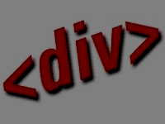

Hints :

Tag <div> :

The HTML <div> tag is used for defining a section of your document.  With the div tag, you can group large sections of HTML elements together and format them with CSS.  By default, browsers always place a line break before and after the <div> element. However, this can be changed with CSS.

Syntax :

 <div> XXX </div>

Content :  
div - We help you make more of your events <br>  
Eventsforce helps you manage events more effectively by simplifying your everyday tasks and processes. It can deliver all the functionality you require for any type of event regardless of size or complexity. More importantly, Eventsforce solutions can help you save time, cut costs and make better use of your event data.  
<br>  
div - We care about your events<br>  
At Eventsforce, we care that you succeed. We believe that technology alone is not enough to deliver sustainable results for your events and we are committed to offering more. From event planning and account management to support services and software development the collective experience of our staff helps us bring a collaborative approach to customers, which is reflected across everything we do.  
<br>  
div - We understand our customers<br>  
Eventsforce is the preferred technology partner for events professionals working in a broad range of industries from associations to corporations, universities to government and PCOs to agencies. We have considerable experience and history of supporting organisations across all these industries and take pride in understanding what matters most to the events professionals working for them.  
<br>  
  
Constraints :  
3 'div' tags should be present in the html page.  
The first div tag must have the id 'firstDiv'.  
The second div tag must have the id 'secondDiv'.  
The third div tag must have the id 'thirdDiv'.  
  
Note :  
Content of the page should be present as shown in the screenshot.  
Kindly refer the content which is given as a part of description.  
  
Sample Screenshot 1 :  
  
